Website:

A website is a collection of web pages and related content that is identified by a common domain name and published on at least one web server.

Web Development:

It refers to the building, creating, and maintaining of websites. It includes aspects such as web design, web publishing, web programming, and database management. It is the creation of an application that works over the internet i.e., websites.

It can be classified in two ways

1. Frontend Development:

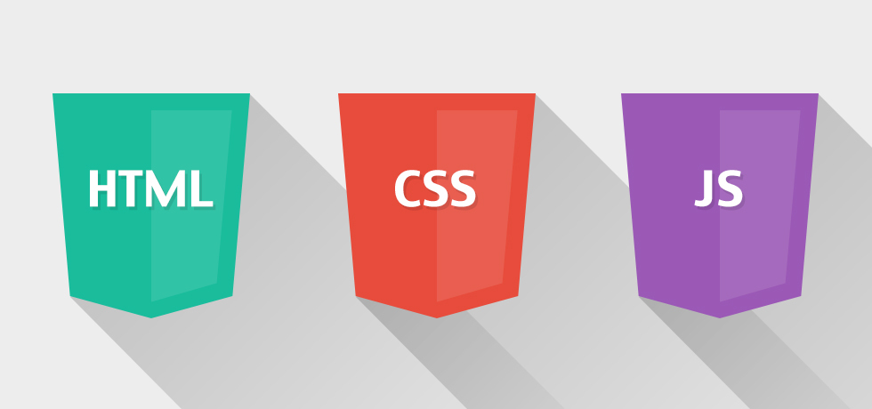The part of a website that the user interacts directly is termed as front end.

[HTML](https://www.geeksforgeeks.org/html-tutorials/): HTML stands for Hypertext Markup Language. It is used to design the front-end portion of web pages using markup language. It acts as a skeleton for a website since it is used to make the structure of a website.

[CSS](https://www.geeksforgeeks.org/css-tutorials/): Cascading Style Sheets fondly referred to as CSS is a simply designed language intended to simplify the process of making web pages presentable. It is used to style our website.

[JavaScript](https://www.geeksforgeeks.org/javascript-tutorial/): JavaScript is a scripting language used to provide a dynamic behaviour to our website.

1. Backend Development:

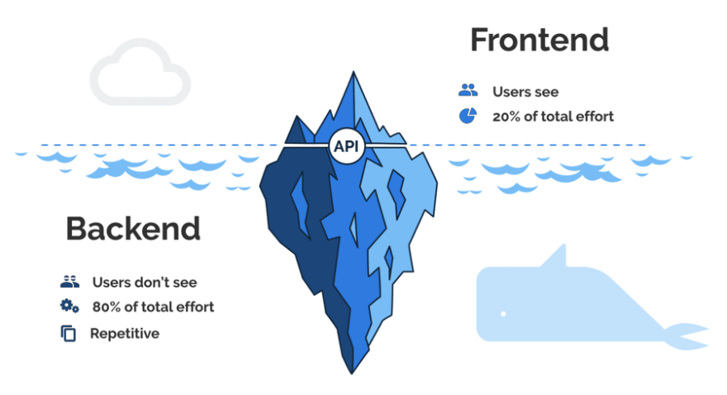Backend is the server side of a website. It is the part of the website that users cannot see and interact. It is the portion of software that does not come in direct contact with the users. It is used to store and arrange data.

[PHP](https://www.geeksforgeeks.org/php-tutorials/): PHP is a server-side scripting language designed specifically for web development.

[Java](https://www.geeksforgeeks.org/java-tutorial/): Java is one of the most popular and widely used programming language. It is highly scalable.

[Python](https://www.geeksforgeeks.org/python-programming-language/): Python is a programming language that lets you work quickly and integrate systems more efficiently.

[Node.js](https://www.geeksforgeeks.org/nodejs-tutorials/): Node.js is an open source and cross-platform runtime environment for executing JavaScript code outside a browser.

Back End Frameworks: The list of back end frameworks are: [Express](https://www.geeksforgeeks.org/introduction-to-express/), [Django](https://www.geeksforgeeks.org/django-tutorial/), [Rails](https://www.geeksforgeeks.org/how-to-install-ruby-on-rails-on-windows-and-linux/), [Laravel](https://www.geeksforgeeks.org/tag/laravel/), [Spring](https://www.geeksforgeeks.org/introduction-to-spring-framework/), etc.

WHO IS A WEB DEVELOPER?

Web developers create and maintain websites. They are also responsible for the site's technical aspects, such as its performance and capacity, which are measures of a website's speed and how much traffic the site can handle. In addition, web developers may create content for the site.

<DOCTYPE! html>:

This is the document type declaration (not technically a tag). It declares a document as being an HTML document. The doctype declaration is not case-sensitive.

<html>:

This is called the HTML root element. All other elements are contained within it.

<head>:

The head tag contains the “behind the scenes” elements for a webpage. Elements within the head aren’t visible on the front-end of a webpage. HTML elements used inside the <head> element include:

**<style>**

**<title>**

**<base>**

**<noscript>**

**<script>**

**<meta>**

**<link>**

<body>:

The body tag is used to enclose all the visible content of a webpage. In other words, the body content is what the browser will show on the front-end.

An HTML document can be created using any text editor. Save the text file using .html or .htm. Once saved as an HTML document, the file can be opened as a webpage in the browser.

Basic/built-in text editors are Notepad (Windows) and TextEdit (Macs).

Example: **This example illustrates the basic structure of HTML code.**

<!DOCTYPE html>

<html>

<head>

    <title>Demo Web Page</title>

</head>

<body>

    <h1>Hello</h1>

<p>A web technology class</p>

</body>

</html>

HTML Page Structure

Below is a visualization of an HTML page structure

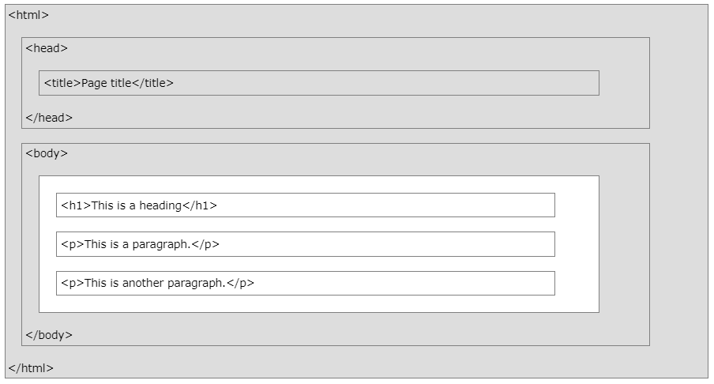

The Submit Button

- The <input type="submit"> defines a button for submitting the form data to a form-handler.

- The form-handler is typically a file on the server with a script for processing input data.

- The form-handler is specified in the form's action attribute.

<!DOCTYPE html>

<html>

<body>

<h2>The name Attribute</h2>

<form action="/action_page.php">

<label for="fname">First name:</label><br>

<input type="text" id="fname" value="John"><br><br>

<input type="submit" value="Submit">

</form>

<p>If you click the "Submit" button, the form-data will be sent to a page called "/action_page.php".</p>

<p>Notice that the value of the "First name" field will not be submitted, because the input element does not have a name attribute.</p>

</body>

</html>

- CSS is the language we use to style an HTML document.

- CSS describes how HTML elements should be displayed.

**What is CSS?**

* CSS stands for Cascading Style Sheets
* CSS describes how HTML elements are to be displayed on screen, paper, or in other media
* CSS saves a lot of work. It can control the layout of multiple web pages all at once

External stylesheets are stored in CSS files

**Why Use CSS?**

CSS is used to define styles for your web pages, including the design, layout and variations in display for different devices and screen sizes.

CSS Saves a Lot of Work!

The style definitions are normally saved in external .css files.

With an external stylesheet file, you can change the look of an entire website by changing just one file

<!DOCTYPE html>

<html>

<head>

<style>

body {

background-color: lightblue;

}

h1 {

color: white;

text-align: center;

}

p {

font-family: verdana;

font-size: 20px;

}

</style>

</head>

<body>

**CSS Syntax**

- The selector points to the HTML element you want to style.

- The declaration block contains one or more declarations separated by semicolons.

- Each declaration includes a CSS property name and a value, separated by a colon.

- Multiple CSS declarations are separated with semicolons, and declaration blocks are surrounded by curly braces.

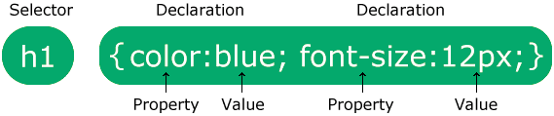

**In this example all <p> elements will be center-aligned, with a red text color:**

<!DOCTYPE html>

<html>

<head>

<style>

p {

color: red;

text-align: center;

}

</style>

</head>

<body>

<p>Hello World!</p>

<p>These paragraphs are styled with CSS.</p>

</body>

</html>

**Example Explained**

* p is a selector in CSS (it points to the HTML element you want to style: <p>).
* color is a property, and red is the property value
* text-align is a property, and center is the property value

**What is Bootstrap?**

* Bootstrap is a free front-end framework for faster and easier web development
* Bootstrap includes HTML and CSS based design templates for typography, forms, buttons, tables, navigation, modals, image carousels and many other, as well as optional JavaScript plugins
* Bootstrap also gives you the ability to easily create responsive designs

**Bootstrap History**

Bootstrap was developed by Mark Otto and Jacob Thornton at Twitter, and released as an open source product in August 2011 on GitHub.

Advantages of Bootstrap:

* **Easy to use:** Anybody with just basic knowledge of HTML and CSS can start using Bootstrap
* **Responsive features:** Bootstrap's responsive CSS adjusts to phones, tablets, and desktops
* **Mobile-first approach:** In Bootstrap 3, mobile-first styles are part of the core framework
* **Browser compatibility:** Bootstrap is compatible with all modern browsers (Chrome, Firefox, Internet Explorer, Edge, Safari, and Opera)

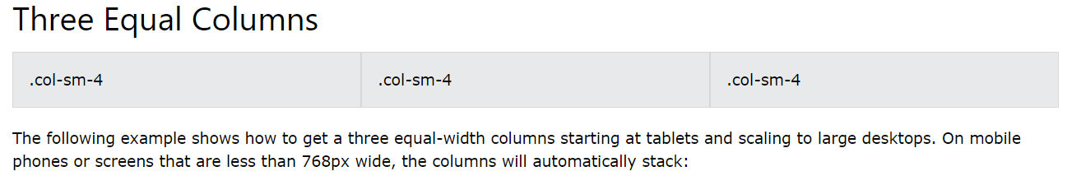<!DOCTYPE html>

<html lang="en">

<head>

<title>Bootstrap Example</title>

<meta charset="utf-8">

<meta name="viewport" content="width=device-width, initial-scale=1">

<link rel="stylesheet" href="https://maxcdn.bootstrapcdn.com/bootstrap/3.4.1/css/bootstrap.min.css">

<script src="https://ajax.googleapis.com/ajax/libs/jquery/3.5.1/jquery.min.js"></script>

<script src="https://maxcdn.bootstrapcdn.com/bootstrap/3.4.1/js/bootstrap.min.js"></script>

</head>

<body>

<div class="container-fluid">

<h1>Hello World!</h1>

<p>Resize the browser window to see the effect.</p>

<p>The columns will automatically stack on top of each other when the screen is less than 768px wide.</p>

<div class="row">

<div class="col-sm-4" style="background-color:lavender;">.col-sm-4</div>

<div class="col-sm-4" style="background-color:lavenderblush;">.col-sm-4</div>

<div class="col-sm-4" style="background-color:lavender;">.col-sm-4</div>

</div>

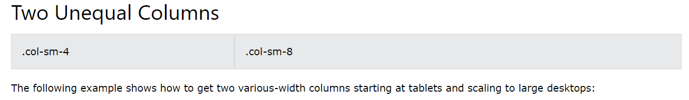</div></body></html>

<!DOCTYPE html>

<html lang="en">

<head>

<title>Bootstrap Example</title>

<meta charset="utf-8">

<meta name="viewport" content="width=device-width, initial-scale=1">

<link rel="stylesheet" href="https://maxcdn.bootstrapcdn.com/bootstrap/3.4.1/css/bootstrap.min.css">

<script src="https://ajax.googleapis.com/ajax/libs/jquery/3.5.1/jquery.min.js"></script>

<script src="https://maxcdn.bootstrapcdn.com/bootstrap/3.4.1/js/bootstrap.min.js"></script>

</head>

<body>

<div class="container-fluid">

<h1>Hello World!</h1>

<p>Resize the browser window to see the effect.</p>

<p>The columns will automatically stack on top of each other when the screen is less than 768px wide.</p>

<div class="row">

<div class="col-sm-4" style="background-color:lavender;">.col-sm-4</div>

<div class="col-sm-8" style="background-color:lavenderblush;">.col-sm-8</div>

</div>

</div></body></html>

**The Following will be an Example of Contextual Tables**

<!DOCTYPE html>

<html lang="en">

<head>

<title>Bootstrap Example</title>

<meta charset="utf-8">

<meta name="viewport" content="width=device-width, initial-scale=1">

<link rel="stylesheet" href="https://maxcdn.bootstrapcdn.com/bootstrap/3.4.1/css/bootstrap.min.css">

<script src="https://ajax.googleapis.com/ajax/libs/jquery/3.5.1/jquery.min.js"></script>

<script src="https://maxcdn.bootstrapcdn.com/bootstrap/3.4.1/js/bootstrap.min.js"></script>

</head>

<body>

<div class="container">

<h2>Basic Table</h2>

<p>The .table class adds basic styling (light padding and only horizontal dividers) to a table:</p>

<table class="table table-striped table-bordered table-hover ">

<thead>

<tr>

<th>Firstname</th>

<th>Lastname</th>

<th>Email</th>

</tr>

</thead>

<tbody>

<tr>

<td>John</td>

<td>Doe</td>

<td>john@example.com</td>

</tr>

<tr>

<td>July</td>

<td>Dooley</td>

<td>july@example.com</td>

</tr></tbody></table>

</div></body></html>

<body>

<div class="container">

<h2>Contextual Classes</h2>

<p>Contextual classes can be used to color table rows or table cells. The classes that can be used are: .active, .success, .info, .warning, and .danger.</p>

<table class="table">

<thead>

<tr>

<th>Firstname</th>

<th>Lastname</th>

<th>Email</th>

</tr>

</thead>

<tbody>

<tr>

<td>Default</td>

<td>Defaultson</td>

<td>def@somemail.com</td>

</tr>

<tr class="success">

<td>Success</td>

<td>Doe</td>

<td>john@example.com</td>

</tr>

<tr class="danger">

<td>Danger</td>

<td>Moe</td>

<td>mary@example.com</td>

</tr>

<tr class="info">

<td>Info</td>

<td>Dooley</td>

<td>july@example.com</td>

</tr>

<tr class="warning">

<td>Warning</td>

<td>Refs</td>

<td>bo@example.com</td>

</tr>

<tr class="active">

<td>Active</td>

<td>Activeson</td>

<td>act@example.com</td>

</tr> </tbody></table></div></body></html>

